MAGIC Telescope PCA — gamma vs hadron
Short name: PCATel. 19,020 CORSIKA showers × 10 Hillas image parameters + class g (12,332 signal) / h (6,688 background).
Problem Statement
IACT Hillas parameters are strongly correlated (fConc–fConc1 r ≈ 0.976; length/width/size r ≈ 0.70–0.77). A 10-D linear screen wastes capacity on duplicate axes. The task is to rotate the card onto principal components, keep the axes that hold the variance, and test whether two PCs beat the two raw length/width columns on a hold-out LinearSVC — without treating PCA as a physics cut.
Solution Strategy
1) Drop NA and split class from the numeric matrix. 2) Heatmap Pearson R. 3) Eigendecompose R; sort λ descending; scree + cumulative %. 4) Standardize columns and fit sklearn PCA; confirm ratios match NumPy. 5) Project to 2 PCs for a class scatter. 6) LinearSVC, 33% test, seed 42, on 2 PCs vs first two standardized originals. 7) Sweep k / n / noise / scale.
Solution
Eigenvalue shares (%): 42.24, 15.75, 10.12, 9.94, 7.42, 6.50, 4.08, 2.20, 1.55, 0.20. Cumulative: PC2 58.0%, PC4 78.1%, PC7 96.1% (the 95% budget). PC1 loads on fSize / fLength / fWidth versus fConc / fConc1. PC2 loads on fM3Long / fAsym versus fAlpha.
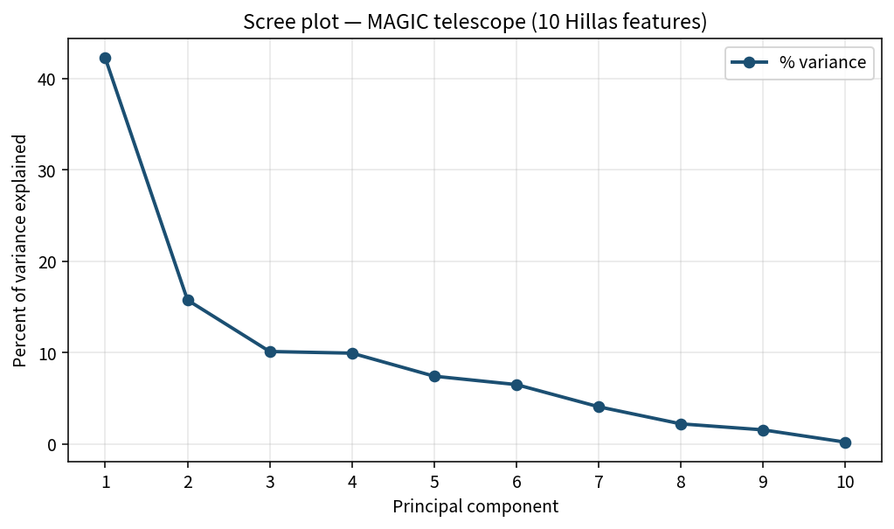
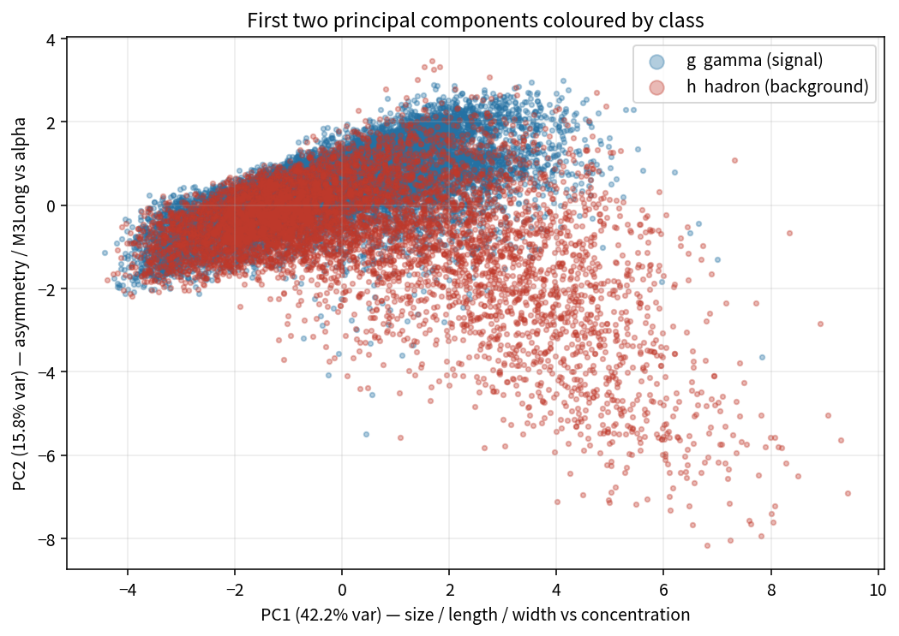
LinearSVC hold-out: 2 PCs 0.742 > fLength+fWidth 0.719 > majority (always g) 0.648. All 10 features: 0.787. The 2-PC map still overlaps — variance ≠ class separation.
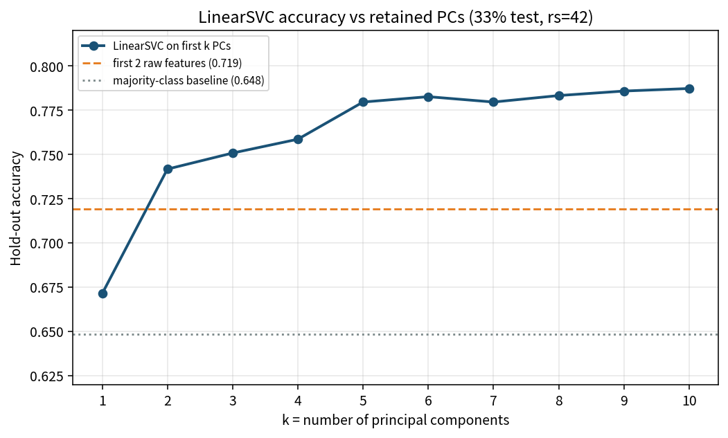
Key Takeaways
• PCA compresses shared Hillas variance; it does not look at g/h while building axes.
• On this card 95% needs ~7 components, not 2 or 3. Two PCs are for a picture, not a variance budget.
• Two PCs already beat the two most obvious raw columns on a linear screen; adding axes climbs toward the full-feature 0.787.
• Standardize first. fDist (~200) would otherwise drown fConc (~0.4).
• Can: compress, visualize, pre-process. Cannot: replace MAGIC G/H, support a flux paper, or treat high-λ directions as signal.

